Round 4 – Manufacturing & Supply: The Battle of Saratoga
The Springfield Armory played a vital role in supporting the Continental Army during the Battle of Saratoga. It will be up to you to repair and supply weapons, ammunition, and produce essential military materials. Your goal is to match the production made by Ezekial Cheever’s invoice in 1778.
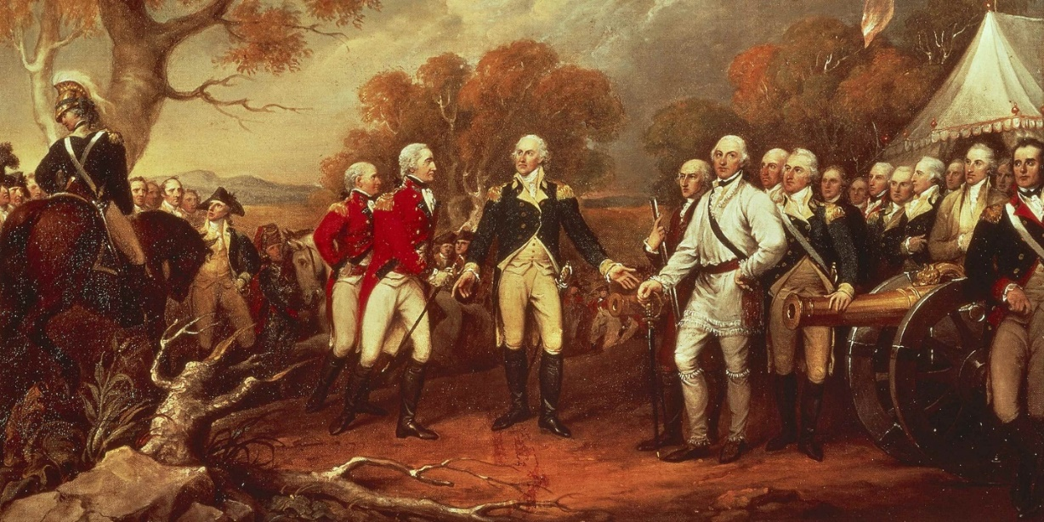

"The Surrender at Saratoga," by Trumbull, circa 1778

The Battle of Saratoga fought in two stages on September 19 and October 7, 1777, proved to be a turning point in the American struggle for independence. It also had a direct impact on the career of General George Washington. Without the victory at Saratoga, American forces would likely not have received critical assistance from the French, and faith in the war effort would have been weakened.
-Troy Smith, George Mason University

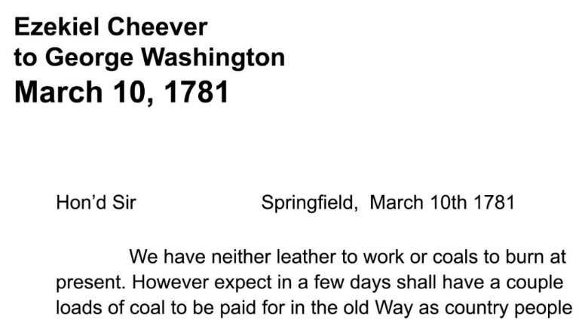
Directions: The Springfield armory had great difficulty acquiring resources to accommodate Washington orders and it was often a “roll of the dice” in terms of availability. Roll the Die provided to determine how many resources your armory will be provided with
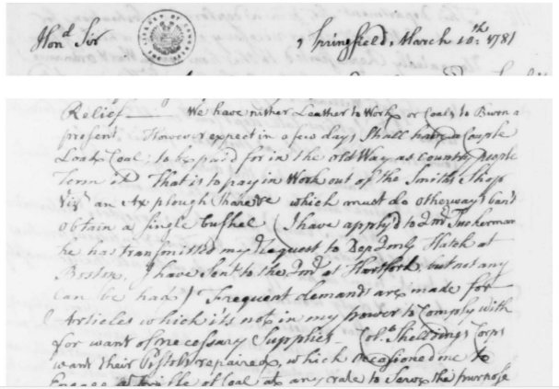

Roll The Die to Determine your availability of Resources.
Roll | Abundance
1–2 | Scarce
3–4 | Moderate
5–6 | Abundant

Material | Purpose | Roll
Iron / Metal: | Needed for barrels, locks, bayonets
Timber / Wood | Needed for gunstocks, wagons, crates
Saltpeter / Charcoal / Sulfur | Needed for gunpowder
Transport / Wagons | Needed to deliver weapons and ammo

Invoice Request to Ezekial Cheever
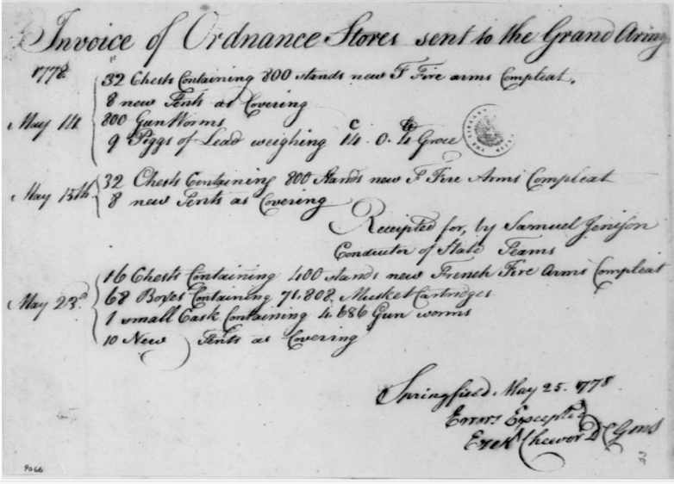
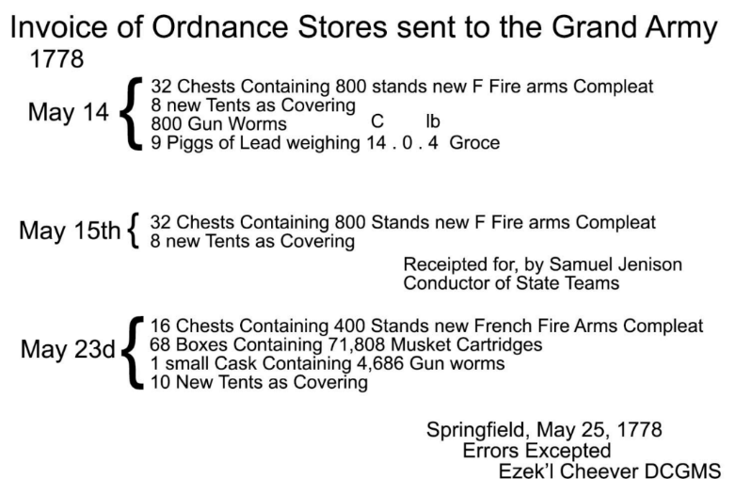

Directions: Take your scores from each roll of your resources and multiple them by your assigned worker value to determine how many pigs of lead, muskets, tent coverings, and Musket cartridges can be produced. Your goal is to match his invoice.
Department | Number from die.   | MULTIPLY | Worker Value. | EQUALS | Quantity Produced | Material
Blacksmiths |  | X |  | = |  | Pigs of Lead
Gunsmiths |  | X |  | = |  | Muskets
Carpenters |  | X |  | = |  | Tent Coverings
Powder / Lab |  | X |  | = |  | Musket Cartridges

